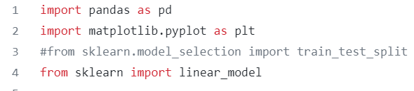

Import pandas, matplotlib, and sklearn in order to use dataframes, graph out correlations, and build out linear models for training and fitting.

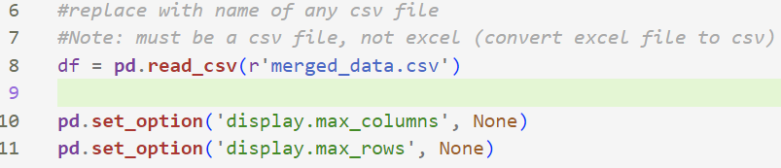

Create pandas dataframe from the csv data. Make pandas display all columns and all rows so that we can see the comprehensive list of correlations for each company with each R-factor score.

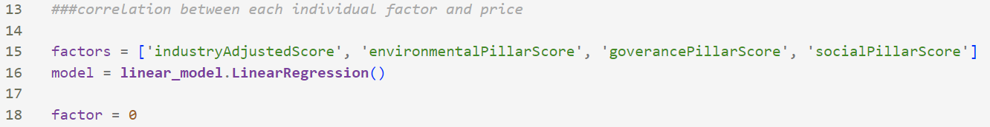

Store the names of the factors (as displayed in the csv sheet) in a list in order to be able to cycle through each R-factor for each of the 500 companies. This will help us for the graphical representation of the R-factor correlations later on in the code. Load the linear regression model and set factor equal to 0 to prepare for the cycling through the list.

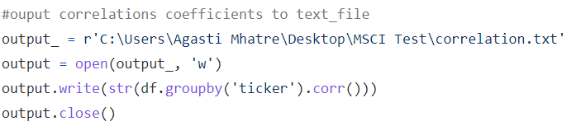

Generate correlations and output the entire set of correlations to a text file for readability. Group data by ticker so that we can get correlation data for each individual company.

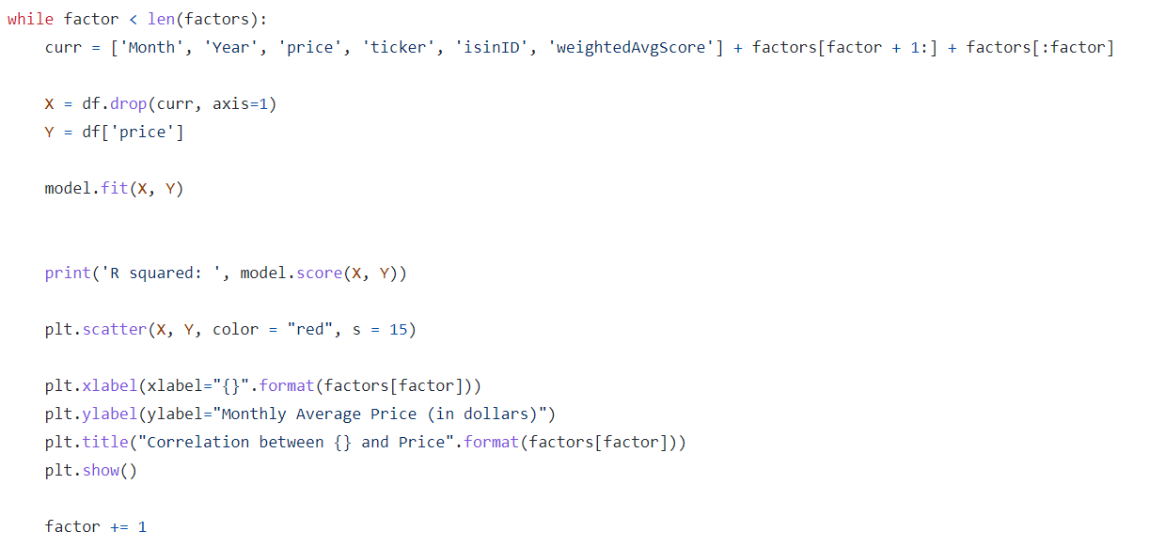

Fit each set of data points for each company/factor into the linear regression model in order to display it through matplotlib’s scatter plot function.